***Thermoregulation Validation Test Marking Key***

1. What was your hypothesis?

Must refer to both the independent and dependent variables and predict the outcome of the investigation.

2. Identify the independent and dependant variables in this investigation

Dependent on experiment. Must be specific to get to the mark

(eg. DV: Temperature of plasticine after 5 mins – NOT temperature)

3. Identify **three** extraneous (uncontrolled) variables in either the **method or** **equipment** used in the investigation. Describe how you could control each variable.

Depends on individual investigation.

1 mark for BOTH identifying uncontrolled variable and describing a way to control it in future.

(3 marks)

4. Describe one risk in this investigation and explain the precautions taken to minimize this risk during data collection.

Risk: Water may be spilled during the investigation and may be a slip hazard for students (1)

Precaution: Ensure any spills are cleaned up immediately (1)

Any other **reasonable** suggestions

(2 marks)

5. Biologist would often need to analyse their data before identifying patterns and trends. Below is a collection of second data regarding temperature change in an ectotherm over a 25 minute period of time. Calculate the mean, median and range of the core body temperatures provided. You must show full working to receive full marks.

|  |  |
| --- | --- |
| **Time (minutes)** | **Core Body Temperature (°C)** |
| 0 | 20 |
| 5 | 23 |
| 10 | 25 |
| 15 | 27 |
| 20 | 29 |
| 25 | 32 |

Mean = (20 + 23 + 25 + 27 + 29 + 32)/6 = 26 °C (1)

Median = (25 + 27)/ 2 = 26 °C (1)

Range = 32 – 20 = 12 °C (1) + 1 mark for units

(4 marks)

6. Describe an advantage of using the median rather than the mean in the analysis data.

Mean can be greatly affected by outliers (1)

Whereas outliers have less of an effect on median as it only offsets the median by one place (1) (2 marks)

7. Construct a graph of your average results collected in your investigation.   
Title – includes both independent and dependent variables (1)

Axes labels and scale (1)

Correct units given (if applicable) (1)

Appropriate type of graph – line vs. bar (1)

Data plotted correctly/ neatness (1)

8. Use evidence from your data to describe patterns or trends in your results.

Pattern or trend visible in graph well described (1)

Specific numerical data referred to (1)

(2 marks)

9. What conclusions can be made based on your results? Refer to methods of heat transfer in your explanation.

Explanation of why these results occurred (1)

Correct reference to conduction, convection or radiation in relation to heat gain/loss (1)

(2 marks)

10. Discuss two advantages of using plasticine in the investigation instead of living ectotherms.

• No ethical considerations in this investigation, as no animals are unfairly treated (1)

• Easy to manipulate plasticine into specific shapes and sizes when changing surface area to volume ratio rather than having to identify living ectotherm with varying SA:V ratios (1)

• Easier to repeat the experiment as plasticine can be reused, whereas a large number of ectotherms may be needed in order to collect reliable data (1)

• Easier to source large amounts of plasticine rather than needed to capture or breed large numbers of ectotherms (1)

**Must state the advantage of using plasticine OVER a living ectotherm**

(2 marks)

11. Discuss two limitations of using plasticine instead of living ectotherms.

• Shapes of plasticine does often not reflect the body shape of a real ectotherm – heat exchange may occur at a different rate in reality (1)

• Properties of plasticine material differ from that of a real ectotherm and this may affect heat exchange (1)

• Plasticine lacks circulatory system that would normal assit is changing core temperature as external temperatures change – data may not accurately reflect changes in ectotherms (1)

(2 marks)

12. How would you expect your results to vary if this investigation were repeated using living ectotherms? Explain your answer.

Heat transfer would occur at a quicker rate/ plasticine would heat up or cool down quicker (1)

Internal transport systems would speed up the rate of heat exchange (1)

Behavioural responses may alter heat exchange (1)

(2 marks)

13. Were your results reliable? Explain your answer.

No (1) – not enough trails/repetition to consider results reliable (1)

(2 marks)

14. Were your results valid? Explain your answer.

No (1) – uncontrolled variables may have effected the results, making them invalid (1)

(2 marks)

Consider the following second hand data about Adelie Penguins to answer the following question.

15. One area of the Adelie Penguin’s body surface that is not well insulated is its feet. This could be a problem for a bird that spends a lot of time standing on ice or immersed in icy water.

An investigation was carried out to try and determine the mechanisms that enable the penguin to tolerate such cold conditions around its feet. Under laboratory conditions in an Antarctic research station, a penguin was connected to two continuous temperature sensors. One measured the temperature in a foot and the other measured core body temperature. The penguin was made to stand in icy sea water at -1.5°C. After 90 minutes, the foot was injected with a substance that causes the muscles in the wall of the blood vessels to relax. The results of this investigation are shown below.

Core Body Temperature (°C)

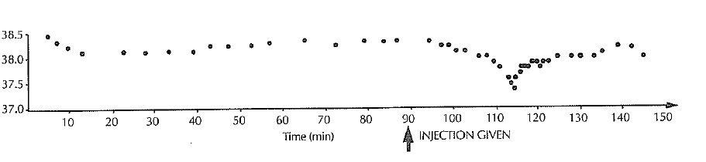

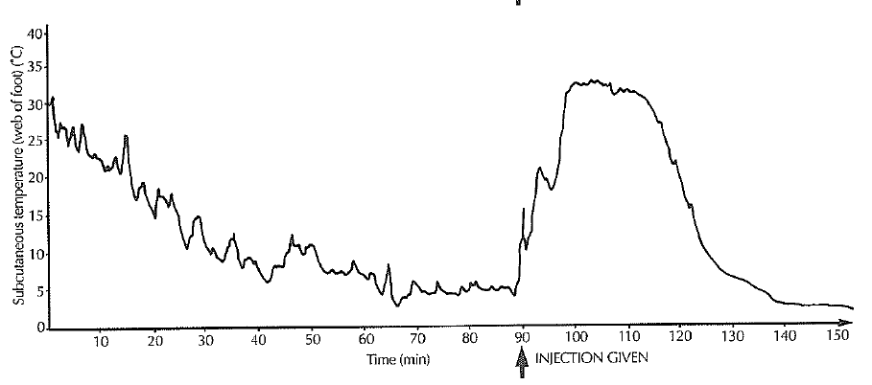

1. From the information provided in the graph above, explain how the Adelie penguin normally reduces heat loss from its feet.

Before the injection (0-90mins) the feet are significantly colder than the core temperature (1).

This is due to vasoconstriction of blood vessels to the feet (1)

This reduces blood flow to the feet and hence reduce heat loss (1)

(3 marks)

1. The rate of heat loss changed after the injection of the muscle relaxant. Describe the sequence of events caused by the injection. Discuss both the changes in the foot and in the body.
2. Injection causes vasodilation of blood vessels to the feet (1)
3. This causes an increase in blood flow to the feet (1)
4. As a consequence increased heat is lost by the feet via conduction and radiation (may also say convection) (1)
5. After the blood has cooled in the feet it returns to the core, resulting in a reduction in core temperature (1)

(4 marks)